Place the mouse cursor over the ‘📌Click here to edit model parameters’ field in the target model; it will turn blue. Click it.

# **Basic Parameter Settings -** *Sufficient for most projects*

In MATLAB Editor, users can edit the following parameters:

|  |  |
| --- | --- |
| **Parameters** | **Notes** |
| PWM_frequency | [Hz], switching frequency of the power converter. |
| deadtime | [s], a rising edge delay inserted between switching the two IGBTs of the same bridge leg of the power converter to prevent them from conducting simultaneously and causing a short circuit. |
| Ts | [s], sample time for the control system, usually set to the reciprocal of the PWM frequency. |
| target.comport | The COM port for DL RCPCORE recognized on the PC, which can be found in the Device Manager. |

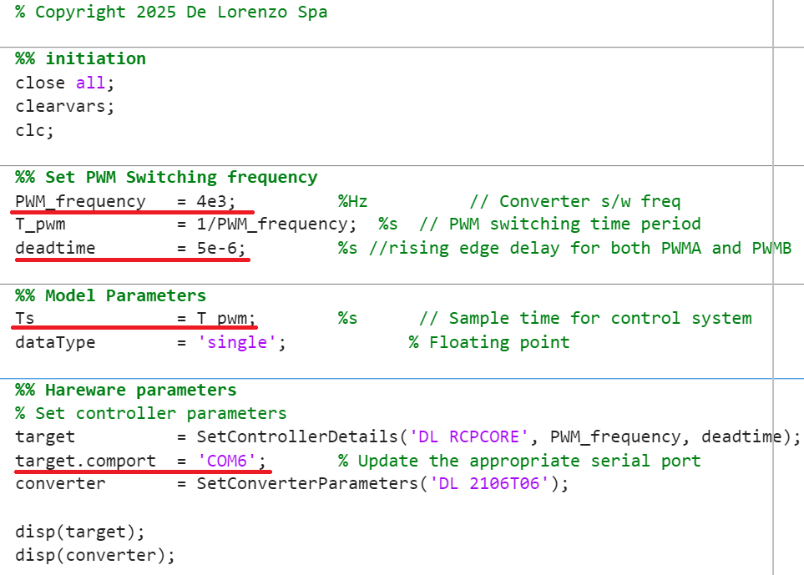

# **Advanced Parameter Settings –** *for deep customization*

## **DL RCPCORE Parameters**

Find the ‘**SetControllerDetails**’ function in the script, place the cursor inside the function, and then press **Ctrl+D** or right-click and select **Open "SetControllerDetails"** to edit the function.

The parameters that can be modified in the **case {'DL RCPCORE'}** are as follows:

target.SCI_baud_rate specifies the baud rate for real-time communication between the target and host models.

target.Offset_x represent the hardware offsets of the corresponding high-voltage and low-voltage measurement channels in the DL RCPCORE at 0V, used for static hardware calibration.

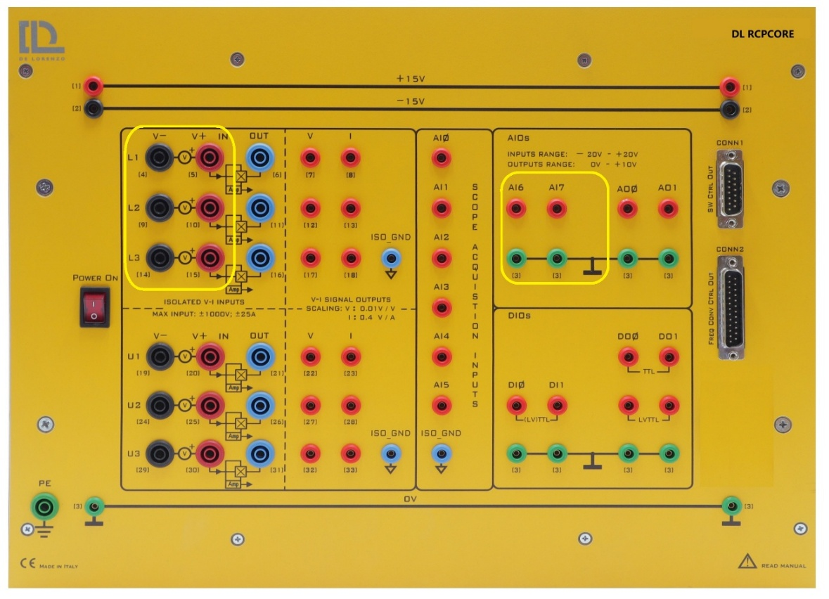

## **DL 2106T06 Parameters**

Find the ‘**SetConverterParameters**’ function in the script, place the cursor inside the function, and then press **Ctrl+D** or right-click and select **Open "** **SetConverterParameters"** to edit the function.

The parameters that can be modified in the **case {'DL 2106T06'}** are as follows:

converter.xOffset represent the hardware offsets of the corresponding analogue signal measurement channels in the DL 2106T06 at 0V, used for static hardware calibration.

